Stack:

1. Introduction
2. ADT stack

It works on last in first out.

It is collection of elements. In stack last element can be deleted first

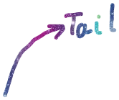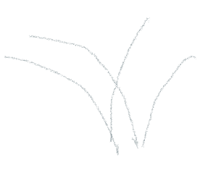

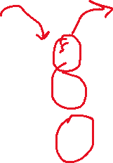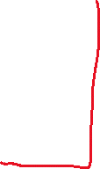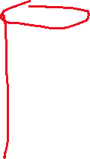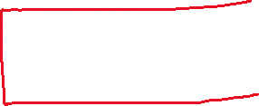

Recursions:

Recursion are the functions which calls itself. It’s behaviiour is

Like a loop but they are internally used in stack.

Some recursion are directly convertible into iteration but some recursion are needed stack

And viseversa.

Note:

Every recursion can be converted into iteration. And every iteration can be conveted

Into recursion.

ADT stack:

It is the definition of stack in terms of data representation and operation.

Data:

1. Space for storing elements.
2. Top pointer.

Operations:

1. Push( ) : Inserting a value.
2. Pop( ) : Deleting a value
3. Peek(Index): looking at the value at the given position. It’s not deleting

.just knowing what is there.

1. StackTop( ): It’s not deleting just knowing what is at topmost value.
2. .isEmpty( ): Knowing wether stack is empty or stack is full.
3. .isFull( ):

In stack insertion and deletaion always takes place from the top

.inside the stack.

|  |
| --- |
|  |
| 15 |
| 20 |
| 16 |
| 10 |

4



3

2

1

0

We can store collection of elements –

1. Array
2. Linked-list.